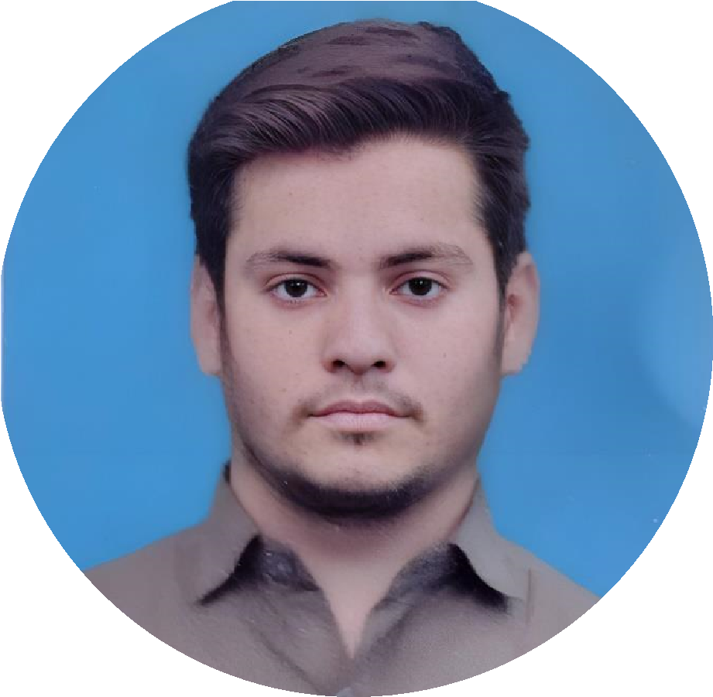




MUHAMMAD SHOIAB

KHAN

ABOUT ME

To secure a
responsible position in
your organization where the
company can utilize my abilities to
the maximum and I can grow
professionally as well as functionally
as same time

EDUCATION

MATRIC

Grade: A

Percentage:
79
%

Board: Karachi

Passing Year: 2019

INTERMEDIATE

Grade: A

Percentage:
7
%
6

Board: Karachi

Passing Year: 20
21

GRADUATION

BSCS (Continue)

University: Federal Urdu University Of
Arts Science And Technology

EXPERIENCE

FIRST
COMPANY

The Karachi Traders

(
Public Relation Officer)

CONTACT

SKILLS

Shoaib.amin998@gmail.com

+923
171034800

House no.3, Street no. 16, Sector 4/F

Mujahid Colony Orangi Town

Karachi.

WEB
DEVELOPMENT

MS OFFICE

ENGLISH (BASIC)
PASHTO
URDU
LANGUAGES
WORDPRESS

